1st ERASMUS STAFF TRAINING WEEK
AT THE UNIVERSITY OF CRETE

3 July (Monday) Venue: Senate Chamber, “Rectorate” building, University Campus, Rethymno.
REGISTRATIONS - WELCOME
9:00 – 9:30 Registration, Senate Chamber, “Rectorate” building.

9:30 – 9:45 Official Opening. “Presentation of the University of Crete”: by the Deputy- Rector
for Academic Affairs of the UoC, Erasmus Institutional Coordinator Professor
Mr. Ioannis Karakassis.
9:45 – 9:50 Welcome speech by the Vice Mayor of Culture and Tourism in Municipality of
Rethymno, Ms. Pepi Mpirliraki.
9:50 – 10:00 Welcome speech by the Head of International Relations in Rethymno,
Ms. Eirini Thymiatzi.
10:00 – 10:10 Welcome speech by the Acting Head of International and Public Relations,
Ms. Evi Kortsidaki.

CRETAN HISTORY, CIVILIZATION, LANGUAGE (part I)

10:10 – 10:25 “The History of Crete in Comics”: the history of Crete, through Panagiotis
Giakas’ Book, presented by the Laboratory Teaching Staff of Papyrology and Epigraphy in the Department of Philology, Dr. Nikos Litinas.

CRETAN HISTORY , CIVILIZATION, LANGUAGE (part II)
10:25 – 10:50 “Roman Crete through written ostraca and cave inscriptions”, by the Laboratory Teaching Staff of Papyrology and Epigraphy in the Department of Philology, Dr. Nikos Litinas.

10:50 – 11:10 COFFEE BREAK

11:10 – 12:00 “Interactive practice in making squeezes of inscriptions and writing on
potsherds”. The participants will have the opportunity to create their own real
script. (All materials required will be provided). Instructions and support by
the Laboratory Teaching Staff of Papyrology and Epigraphy in the
Department of Philology, Dr.
Nikos Litinas.

ICE BREAKING
12:00 – 13:00 Presentation of the Participants: Each Participant will be presented in 1
minute, as well as his/her Home University and expectations for the event,
through an ice breaking game.

13:00 – 13:30 COFFEE BREAK

CRETAN HISTORY , CIVILIZATION, LANGUAGE (part III)
13:30 – 14:30 “Greek Language Course”. The participants will have the opportunity to learn Greek (beginner level), through role playing, by the Laboratory Teaching Staff, teacher of Modern Greek as foreign language in the Department of Philology, Dr. Maria Poulopoulou. ***********************************************

20:30 WELCOME DINNER, “En PLO” Restaurant, str.Em.Kefalogianni n.28
(Old town region). Celebration of the 30th anniversary of Erasmus Programme.

4 July (Tuesday) VENUΕ: Main entrance of the UoC Library.
9:00 – 10:00 Guided tour in library.

ERASMUS MOBILITY FOR STUDIES

Amphitheatre D6 (auditorium “Alexandropoulos”)
10.15 – 10.30 “Greek myth: a world of mobility” by Dr Katerina Ladianou, Laboratory Teaching Staff of the Department of Philology.

10:30 – 10:45 “A student’s experience” by graduate from
the Department of History and Archaeology, Mr Lampros Kampourakis,
His story was one of the Success Stories of the National Agency for 2015-16.

10:45 – 11:00 “Six years’ experience in the career of an Erasmus Academic Coordinator” by Assistant Professor, Departmental Coordinator in the Department of Psychology, Mr Elias Economou.

11:00– 12:00 WORKSHOP 1
Small groups’ discussion about the main issues of Erasmus Mobility for Studies (SMS) – classes “B1-15”, “B1-29A”, “B1-26”, “Hall Political Science”.

12:00 – 12:15 COFFEE BREAK

ERASMUS MOBILITY FOR TRAINEESHIP

Amphitheatre D6 (Auditorium “Alexandropoulos”)
12:15 – 12:25 “A student’s experience” by a graduate student from the Department Primary Education, Ms Nikoleta Vogiatzaki.

12:25 – 13:40 WORKSHOP 2.
Small groups’ discussion about the main issues of Erasmus Mobility for Traineeship (SMP) – classes “B1-15”, “B1-29A”, “B1-26”, “Hall of Political Science”.

13:40 – 14:10 Merge of groups in Amphitheatre D6 (Auditorium “Alexandropoulos”) for conclusions and evaluation of the day.

***************************************************

18:30 Guided Tour in the Old Town, by Ms Ritsa Gioumpaki.

Meeting point: entrance of Hotel “IDEON” (10 Nikolaou Plastira Square, Old Town region).
End of the guided tour at the Public Garden, where the Municipality of Rethymno organizes the annual Cretan Diet Festival. Entrance 8€ . Entry: Optional.
Presentation of Cretan products and tasting for free.

5 July (Wednesday) VENUE: “Four Martyrs Church”, Four Martyrs’ square, Koundouriotou str.

EXCURSION
08.00 Meeting point “Four Martyrs Church”, Four Martyrs’ square, Koundouriotou str.
1st visit to Arkadi 8:30 – 9:30
Continuing to Eleftherna 9:45 – 11:45
Last visit: Margarites 12:00 – 13:00

Back to Rethymno, at 13:30

*****************************

20:30 TRADITIONAL CRETAN DINNER, Melina Restaurant, str. Himaras & Katexaki corner, (next to the castle) Old Town region.

6 July (Thursday) VENUE: Amphitheatre D6 (‘Alexandropoulos’)

ERASMUS INTERNATIONAL MOBILITY (KA107)

Amphitheatre D6 (auditorium “Alexandropoulos”)
10:00 – 10:30 "Erasmus+ International mobility: The story of a fruitful encounter"
by the Assistant Professor in the Department of Philology, division Byzantine and Modern Greek Philology, Ms. Natsina Anastasia.
10:30 – 10:40 “The experience of Erasmus Mundus”, by the incoming student, Ms Kinza Saleem (Leader Project) from the University of Bangkok.

10:40 – 11:30 WORKSHOP 3.
Small groups’ discussion about the main issues of Erasmus International Mobility
– classes “B1-15”, “B1-29A”, “B1-26”, “Hall of Political Science”.

11:30 – 11:45 COFFEE BREAK

ERASMUS STAFF TRAINING MOBILITY

11:45 – 12:00 “A Staff Training experience” by the administrative staff of the Faculty of Philosophy, Ms Dora Rozaki.
12:00 – 12:15 “Experiences from teaching mobility through ERASMUS”
Experience of academic staff, Associate Professor, Ms Marianna Kalaitzidaki.
12:15 – 12:30 Experience of academic staff, Associate Professor Ms. Helen Katsarou.

12:30 – 13:30 WORKSHOP 4.
Small groups’ discussion about the main issues of Erasmus Mobility Staff Teaching and Training – classes “B1-15”, “B1-29A”, “B1-26”, “Hall of Political Science”.

13:30- 14:00 Merge of all groups in Amphitheatre no D6 (Auditorium “Alexandropoulos”): conclusions and evaluation of the day and the Staff Week in general.

CLOSING CEREMONY

14:00 – 15:00 The International Relations Office says goodbye with songs and awards the certificates of attendance to all participants.

15:00 – 16.00 Light lunch Buffet

ΧΟΡΗΓΟΙ / SPONSORS
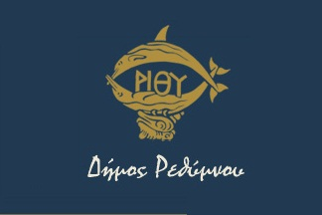 | 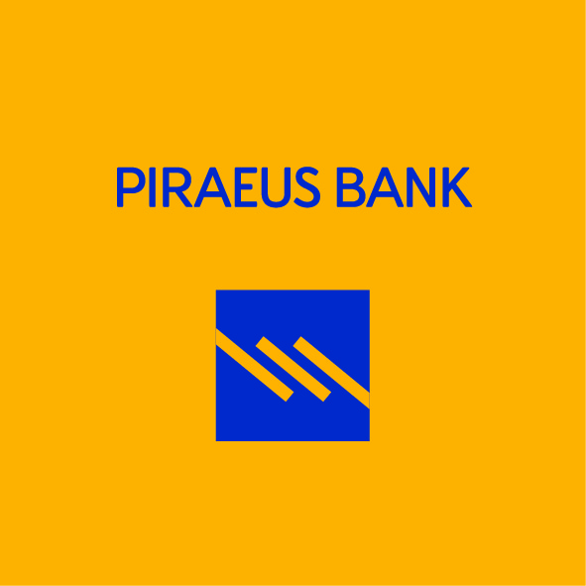 | 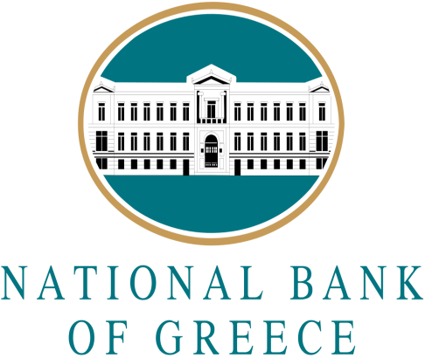
 | 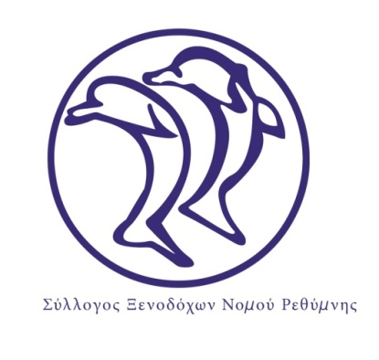 | 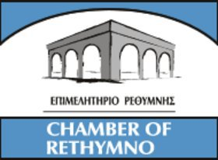
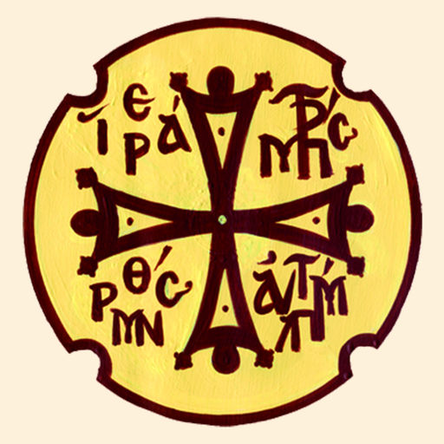 | 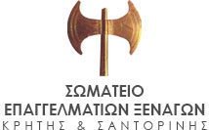 | 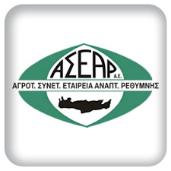
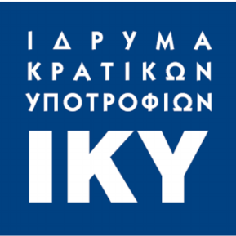 | 